## **Lab 24: Android Seek Bar**

# **Introduction**

A user can slide the thumb back and forth to adjust the progress value in the Android Seek Bar, which is a modified version of the Progress Bar. In our Android device, seek bar can be used for things like brightness and volume control.

**Let’s get Started:**

In this exercise, we will learn how to create Seek Bar in our Android application using Kotlin as our programming language.

**Step 1:** open **activity_main.xml** file from **\res\layout** folder path and write the code like as shown below.

**activity_main.xml**

*<?*xml version="1.0" encoding="utf-8"*?>*<LinearLayout  
 xmlns:android="http://schemas.android.com/apk/res/android"  
 xmlns:tools="http://schemas.android.com/tools"  
 android:id="@+id/container"  
 android:layout_width="match_parent"  
 android:layout_height="match_parent"  
 tools:context=".MainActivity"  
 android:orientation="vertical"  
 android:gravity="center"  
 android:background="#FBC02D"  
 >  
 <TextView  
 android:layout_width="wrap_content"  
 android:layout_height="wrap_content"  
 android:text="Hello Snapchat!"  
 />  
  
 <SeekBar  
 android:id="@+id/seekBar"  
 android:layout_width="match_parent"  
 android:layout_height="wrap_content"  
 android:layout_margin="50dp"  
 android:max="100"  
 android:min="0" />  
</LinearLayout>

**Step 2:** Open main [activity](https://www.tutlane.com/tutorial/android/android-activity-lifecycle) file **MainActivity.kt** and write the code like as shown below.

**MainActivity.kt**

**package** com.example.demopluralsightseekbar  
  
**import** android.os.Bundle  
**import** android.support.v7.app.AppCompatActivity  
**import** android.widget.SeekBar  
**import** android.widget.Toast  
  
**class** MainActivity : AppCompatActivity() {  
  
 **override fun** onCreate(savedInstanceState: Bundle?) {  
 **super**.onCreate(savedInstanceState)  
 setContentView(R.layout.*activity_main*)  
  
 **val** seek = findViewById<SeekBar>(R.id.*seekBar*)  
 seek?.setOnSeekBarChangeListener(**object** :  
 SeekBar.OnSeekBarChangeListener {  
 **override fun** onProgressChanged(seek: SeekBar,  
 progress: Int, fromUser: Boolean) { }  
  
 **override fun** onStartTrackingTouch(seek: SeekBar) {}  
  
 **override fun** onStopTrackingTouch(seek: SeekBar) {Toast.makeText(**this**@MainActivity,  
 **"Progress is: "** + seek.*progress* + **"%"**,  
 Toast.*LENGTH_SHORT*).show()  
 }  
 })  
 }  
}

**Step 3: Check Output on Android Emulator and it should look like as given below.**

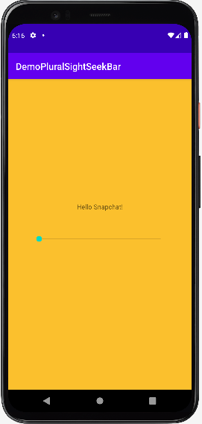 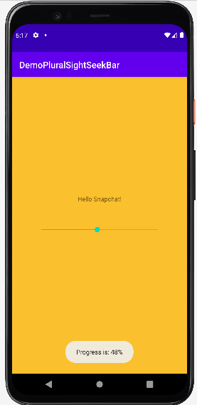

**Voila!!** We have successfully completed this lab.